**Path Based Routing using AWS Application Load Balancer**

* We are trying to realize the following  
  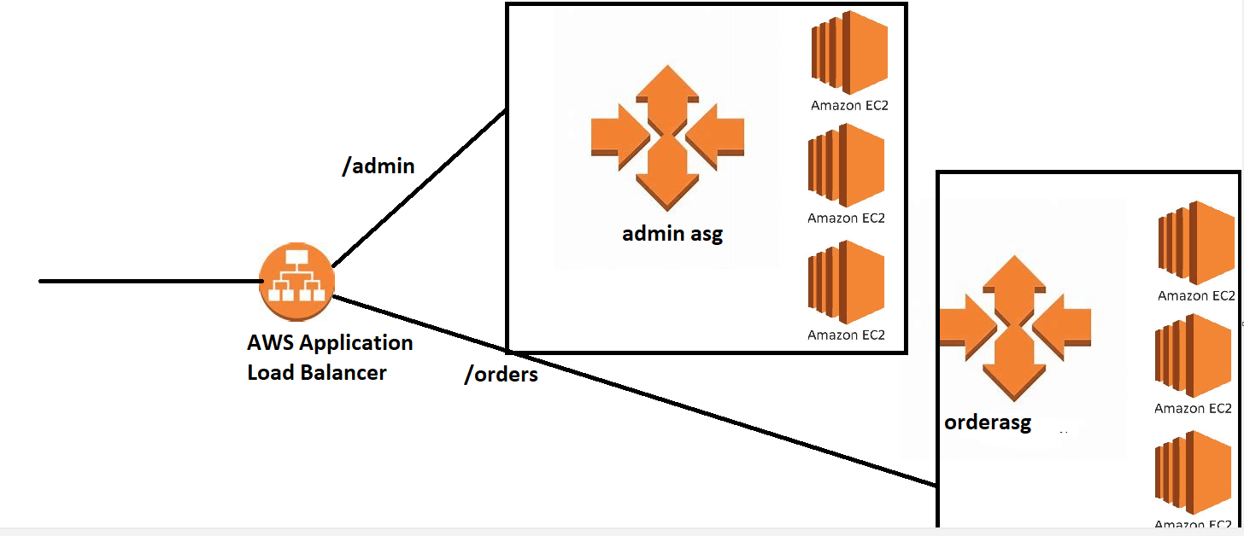
* Steps:
  + Create an autoscaling group with fixed size 1 for ordersami
  + Create an autoscaling group with fixed sized 1 for adminsami
  + Ensure you have launch templates.  
    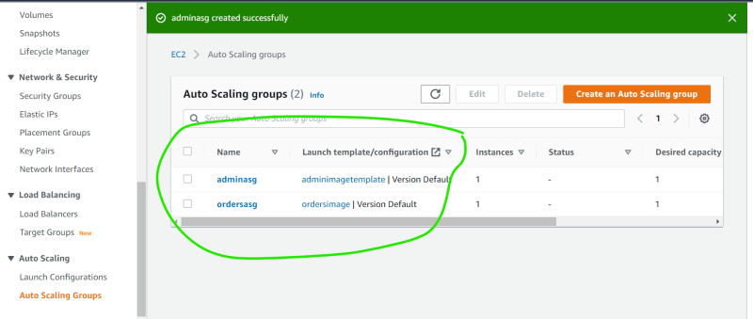
* Now lets create an AWS Application Load Balancer
* Create orders target group and admin target group
* Assign admin target to the Application Load Balancer
* Lets refer Path conditions <https://docs.aws.amazon.com/elasticloadbalancing/latest/application/load-balancer-listeners.html#path-conditions>
* Figure out a way to forward the request to target group by overriding path